Screendox Redesign & Modernization API Specification

Contents

**No table of contents entries found.**

# Home page

## Feature Link

| **ID** | **Work Item Type** | **Title** | **State** | **Effort** | **Business Value** | **Value Area** | **Tags** |
| --- | --- | --- | --- | --- | --- | --- | --- |
| [16](https://dev.azure.com/SSSII/SDx%20-%203Si2/_workitems/edit/16) | Feature | Home | New |  |  | Business |  |

## UI data binding

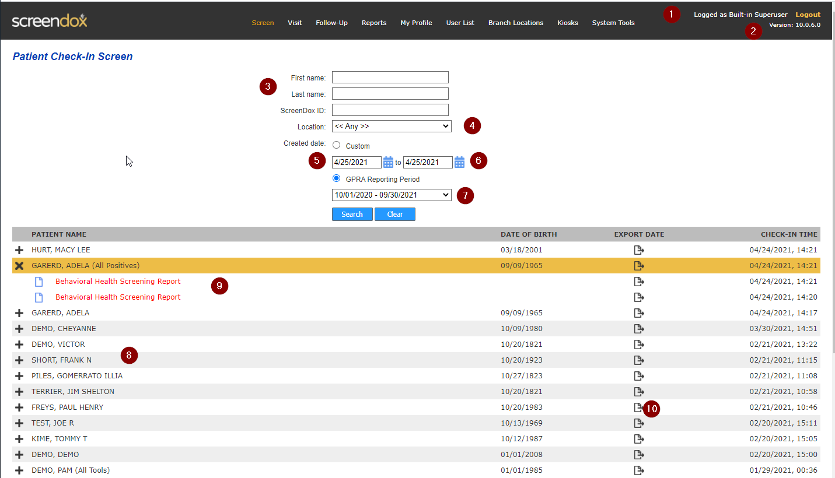

|  |  |  |  |
| --- | --- | --- | --- |
| El. # | Name | API | Comments |
| 1 | Name of logged in user | /api/Profile/Get |  |
| 2 | Version of the application | /api/systeminfo | Version is set at build time and help to verify which version of the application is currently running. For backend that’s the assembly version |

## Comments

* When ScreenDox application does not have license assigned, user is redirected to System Settings / Registration page. (Will be implemented and tested later)

# Screen (Search Screening Results)

## Feature Link

| **ID** | **Work Item Type** | **Title** | **State** | **Effort** | **Business Value** | **Value Area** | **Tags** |
| --- | --- | --- | --- | --- | --- | --- | --- |
| [4](https://dev.azure.com/SSSII/SDx%20-%203Si2/_workitems/edit/4) | Feature | Patient Check-In Screen | Active |  |  | Business |  |

## UI data binding

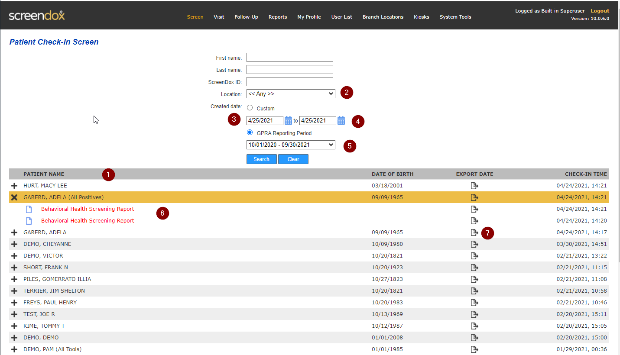

|  |  |  |  |
| --- | --- | --- | --- |
| El. # | Name | API | Comments |
| 1 | Get list of unique patients that has screenings for specific filter condition | /api/screen/search | Unique patient is a unique combination of patient’s name and Date of Birth.  Filter settings currently are stored in user’s session. Need to be stored in cookies and shared across relevant pages.  Check-In Time:   * When same date – show only time. * Otherwise – show full date and time |
| 2 | List of Branch Locations | /api/branchlocation/list | This is the list as data source for Branch Location dropdown across the whole application.  Depending on the user’s role, user can see only his assigned location or all locations.  Currently there is no filter by user’s role, it will be added later with Security |
| 3 | Start date in Date Range filter. | /api/screen/mindate | This filter is common for every form where date range appears. Start date is date to “first available screening” date.  HTTP Cache header is set to 1 year. |
| 4 | End date | N/A | Set to today as default value. Otherwise, it is taken from user’s modified value from cookies. |
| 5 | GPRA periods | /api/screen/gpra | All applicable periods from Oct 1 to Sep 30. The same values on all screens. |
| 6, 7 | List of actual screening results for selected patient | /api/screen/search/{id} | Returns Screening Result with limited number of fields for UI binding.  Red color is set if screening has any positive result (“IsPositive” field)  “Export” icon is used to indicate if screening result has been exported to external EHR (Electronic Health Record).  Fields:   * ShowBeginExportButton. When true, show export icon. When clicked – user redirected to Begin Export / Find Patient screen * ExportDate – show when report has been exported. |

# Screening Result

## Feature Link

| **ID** | **Work Item Type** | **Title** | **State** | **Effort** | **Business Value** | **Value Area** | **Tags** |
| --- | --- | --- | --- | --- | --- | --- | --- |
| [4](https://dev.azure.com/SSSII/SDx%20-%203Si2/_workitems/edit/4) | Feature | Patient Check-In Screen | Active |  |  | Business |  |
| [122](https://dev.azure.com/SSSII/SDx%20-%203Si2/_workitems/edit/122) | User Story | API: Screening result | Resolved |  |  | Business | api |

## UI data binding

|  |  |  |  |
| --- | --- | --- | --- |
| El. # | Name | API | Comments |
| 1 | Get screening result details | /api/screen/{id} | Screening result with all sections – ID: [594](http://screendox.3sicorp.com/screendox/PatientCheckIn.aspx?id=594)  API returns payload with all data about entered patient’s data and answers provided on each screening tool (section).  If patient has not been asked for a screening tool – it’s empty and does not exist in the database.    Sections are returns in the order they display in the screen.  Answer options has main questions when answering “No” to them all other options are skipped.  **TODO: Answer payload will be extended with flag is the answer option is main or not.** |

## Notes

Please use Reports / Screening Results by Sort report to find a test data for checking different options for each tool: <http://screendox.3sicorp.com/screendox/Reports/ScreeningResultsByProblem.aspx>

If no required case – please contact Sergey for adding it to the database.

